Daniel Moir T-Level Digital Production and Design

# Design Documentation

Contents

Design Documentation 1

Typography 2

Initial Typography Ideas 2

Justification & Final Typography Formatting 3

Colour Schemes 3

Initial research about potential colour schemes & Initial colour palette ideas 3

Final design choice 4

Sketches and Layouts 6

Initial sketches and layouts 6

Final sketches and layouts 12

Justification 16

## Typography

### Initial Typography Ideas

|  |  |  |  |
| --- | --- | --- | --- |
|  | Arial | Segoe UI | Blackadder ITC |
| Heading | Headings | Headings | Headings |
| Subheadings | Subheading | Subheading | Subheading |
| Body text | Video provides a powerful way to help you prove your point. | Video provides a powerful way to help you prove your point. | Video provides a powerful way to help you prove your point. |
| Caption |  |  |  |

### Justification & Final Typography Formatting

I will be choosing Arial as the font for my website. This Is because Arial is a sans-serif font making it easy to read and can be easily scaled to any size which Is perfect for a responsive design. The reason I have not choose the other two fonts is because Blackadder ITC is a cursive font and will make readability difficult and for users with difficulty reading it will be an unpleasant experience and will frustrate the users. I also feel like Arial suites the website I am designing as it creates a professional tone and feel for the website compared to Segoe UI which I feel is dull and would not suite the website.

## Colour Schemes

### Initial research about potential colour schemes & Initial colour palette ideas

Colour harmony refers to aesthetically pleasing and harmonious colour combinations based on geometric relationships on the colours wheel. These colours create a website that is pleasing to the eyes and to create these harmonious colour schemes you place geometric shapes on top of the colour wheel and adjusting saturation and brightness needed.

The colours I have been asked to choose are the Runshaw College colour scheme which consists of red, blue and green.

If based on the 60%/30%/10% principal white would be the 60% white, 30% red and 10% green and I will apply the same rule on my website.

To generate the colours below (***Figure 1)*** I used a website called “Adobe colour” (link is on the assets list). I used the *Triadic colour harmony* ***(Figure 2)*** which is a method in which you pick colours based on a triangle. This helps generate contrasting colours.

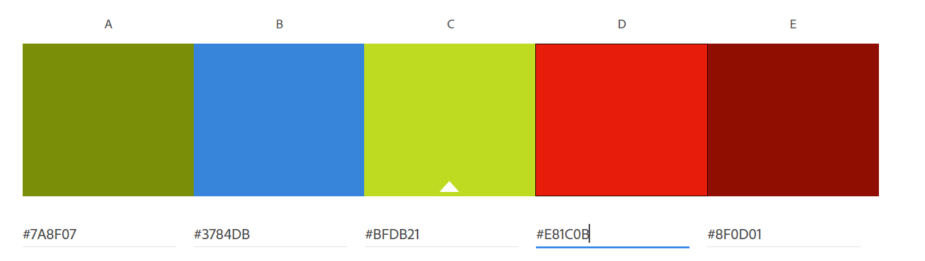

***Figure 1***

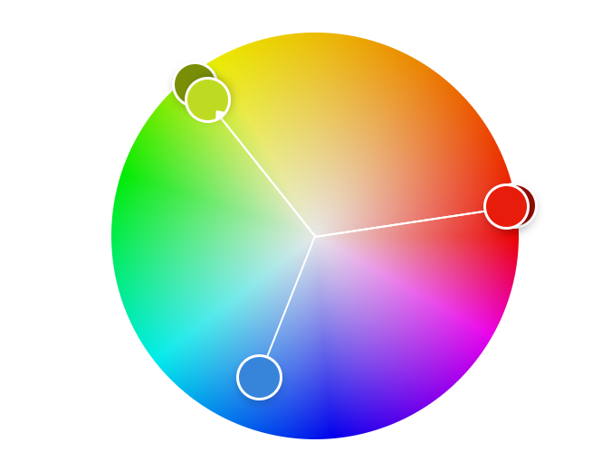

***Figure 2***

The psychology behind these colours fit perfectly with the branding of Runshaw College. Red is among of the most stimulating colours as some sources say it can bring ***energy, passion, and courage but others say power and rage***. Green is the colour of nature and represents a calm and relaxing environment. It can often be described as the colour ***of joy, life, energy, and money***. Blue is ***calming and cool*** and some sources say it is the most popular colour because it symbolises the sky and sea.  
  
The psychology behind these colours create a certain mood for the user when they are using the website. As the website is a college website, I want it to have a welcoming and calm feel to the website while also showing power and competitiveness showing that this is the one of the best colleges there is.

### Final design choice

As colour is very important and can have a positive or negative impact on the user, I need to choose carefully how much or little colour I choose to put on the website when I am designing it. I should aim to choose a dominant colour which will be white and two more that work well with the dominant colour which will be red and green as the accent colours. As mentioned above I will apply the 60/30/10 rule which will be (white, red, green) and the green will be to catch the user’s attention, and this will be used on buttons to indicate to the user that this is important.

Another reason for using these colours as they are accessible and pass the contrast ration on Accessible Colours.com.

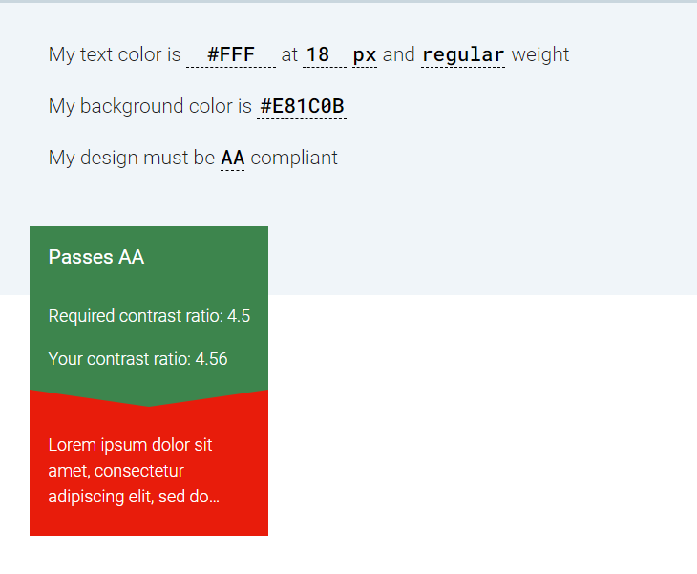

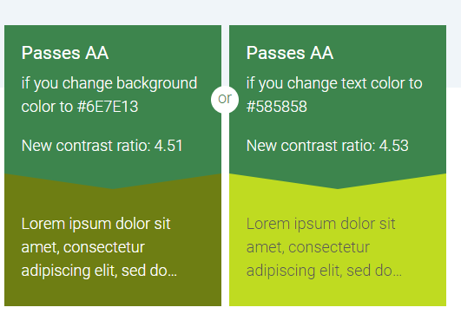

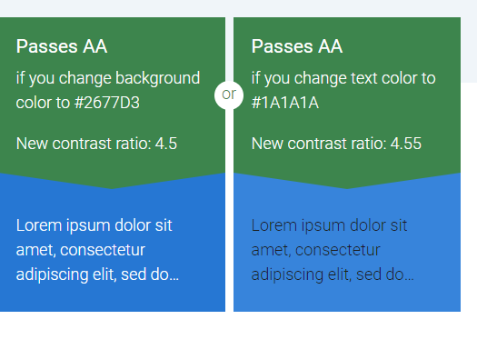

* Background - White
* Text – titles, headings, subheadings body text, captions - Black
* Hyperlinks / Buttons - Green
* Input fields – White

***These are subject to change when designing the wireframes***

## Sketches and Layouts

### Initial sketches and layouts

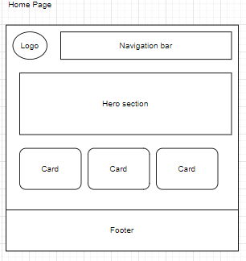

Navigation bar   
Allows the user to navigate throughout the website  
Will have the primary colour of red and when the user hovers over an item in the navigation bar it will underline the text and  
change into a lighter shade to indicate to the user what their mouse is currently on and to provide confirmation.  
It also ensures that the user does not click on the wrong element

Logo  
The logo is positioned at the top right of the webpage, provides the branding, and ensures the user knows that this is a trusted website

Hero section  
Will have a picture of the college in the hero section with some text that say, "Welcome to the Runshaw Eats website". This aims to attract the user’s attention not only to make sure that the user knows what website they are on.

Footer  
The footer will contain social media links, terms of service, copyright, accessibility links that will take them to the page needed

Cards  
These cards will contain a picture of each webpage on the website such as the cafe, history page and gallery. Within these cards (or underneath) there will be a short descriptive to not only inform the user but to entice them to go on another webpage on the website

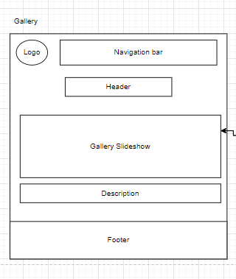

Gallery slideshow  
This will be a slideshow of approx. 5-6 images of the college ranging from the facilities to what the college looks like.  
  
There will be arrows that the user can click and when the user hovers over them it will focus on the arrow drawing the users’ eyes towards it. I will use and arrow icon which is the universal symbol for "next" or "backwards" (depending on the direction).  
  
Once the user clicks on the arrow the slide will move to the direction, they clicked in either left or right and the picture will slide in that direction giving feedback to the user about what they have done.   
  
Additionally, there will be circles or dots at the page which represents how many slides there are in slideshow so the user can go to any picture they desire without having to repeatedly click on the arrows multiple times reducing the time the user has to spend flicking through all the slides and reducing their frustration and giving them control of the website.  
  
Finally, there is a description of the image under the slide and will appear and disappear as the user goes through the images (possibly easing in and out) to give a nice effect of instead of the text popping in and out. A description provides the user context of what is in the image.

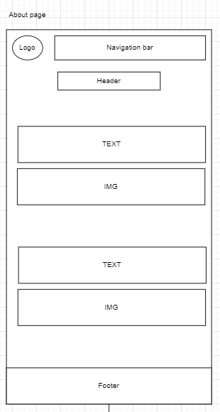

As the about page will be predominantly text, images will be essential on this page.   
Having a balance of images and text will keep the user enticed.

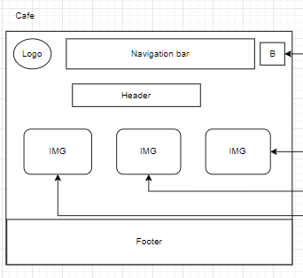

IMG  
These images will contain pictures of the mains, drinks, and snacks, this will indicate to the user what products we have on sale.   
If a user were to click on these pictures they will be taken to the specific menu.   
  
When the user hovers over the images the image will focus indicating to the user that this is something they can click on and ensures that they don’t make any mistakes.

Basket icon  
This will represent the user’s basket. When the user clicks on the icon it will take them to the basket page.

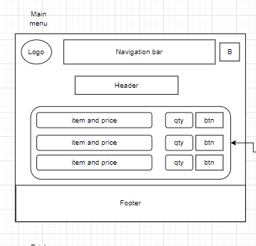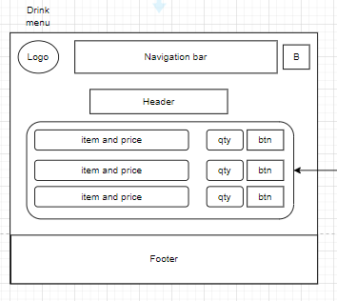

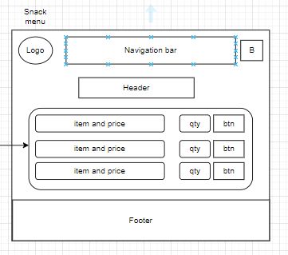

Will contain each item for the menu item in the list, this will have a number input for the quantity and a button next to it which will have a basket icon or plus icon to add that specific item into the user’s basket. Once the user has done that an alert will appear telling the user that they have added an item into their basket  
  
When the user clicks on the button with the plus icon an alert will appear telling the user they have added an item into their basket.

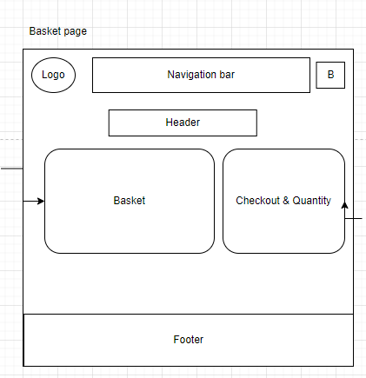

The basket will contain the list of the user's items that they have added to their basket  
  
It will also show the quantity and the amount of the item  
  
The user will also be able to remove and change the quantity of the specific item in their basket. To remove an item there will be a cross icon at the end of the list indicating to the user that this will remove the item. Furthermore, when the user clicks the cross a prompt will appear confirming that this is an item that they want to remove.

This will show the total cost of the user’s basket. Additionally, it will allow the user to checkout or finalise their purchase. Once the user clicks that button it will take them to the checkout page.

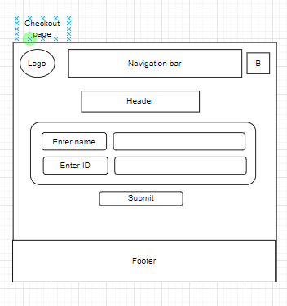

Form  
This allows the user to enter in their details. If a user incorrectly enters their student id an error will appear giving the user confirmation that they have done something wrong. It will be also in red text so it draws the users eyes.  
  
This page will have minimal elements as this will solely be used as a way for the user to confirm that they want to purchase the items in the basket  
  
Once the user has entered in their details and submitted their request, it will be processed to ensure that they have entered in the corrected details and then move over to

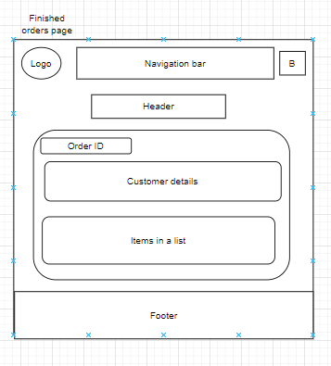

The order table  
  
This page will showcase what the user has purchased, it contains the order ID, the users name, and their ID and underneath a list of items they have bought.

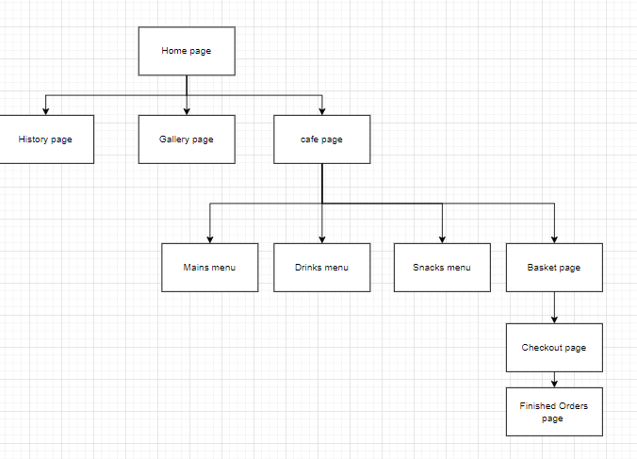

### Final sketches and layouts

### Justification

For my final wireframes I have added colours and images to closely represent what the final website will look like. I have also made some changes, such as the navigation bar and having the basket icon on every page. My justification for adding the basket icon on every page is to allow the user to access their basket from any where on the website making navigation quick and easy. Doing this meant I had to move the navigation bar below the header, and I decided to choose a darker red as I felt like it would attract the users’ eyes towards it, and it made it clear that it was a navigation bar.

Another change I have made is to use the light blue instead of green as I feel like using the colour green for the buttons would not be suitable and I feel like the using the colour blue for the buttons would be more appropriate than using green. I have also left aligned all the tiles on the page, I have done this because after further research majority of websites align their title to the left which improves the Z-Pattern as having the title centre aligned breaks the Z-Pattern.